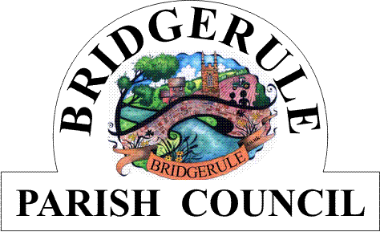

**Minutes of the Extra- Ordinary Parish Council Meeting held on Tuesday 5th August 2025 at 8.00.pm, at Bridgerule Village Hall.**

These minutes are provisional until signed by the Chairman at the next meeting.

**Present :**  Chairman: D Hale

Councillors, J.McDougall, K. James, K. Bowditch, S. Whatmore

In Attendance : Clerk,

Apologies: F. Cogdell. S. Cholwill, M. Tape.

**Declarations of Interests:** The Chairman asked that interests be declared as they arise.

**3562. Discussion of proposed Local Government Reorganisation Plan :** DH welcomed and thanked councillors present for their attendance this and Cllr. KJ for giving a presentation to councillors on potential plans for the LGR and future Unitary councils for Devon. KJ explained that the present government had voted in a bill on Devolution to remove two tier government, that being district and county councils and replace with new larger Unitary single tier councils. Previous rounds of restructuring had taken place since 1992 and up to 2018-2021. The previous government would have preferred the Mayoral option to replace district and county councils. Devon CC had applied to be a Unitary council and defer elections but the government had declined this and CC elections were held in May.

The Mayoral option would consist of a mayor and a strategic board consisting of elected leaders of the new Unitary councils, who reported to the mayor. This option would need to be a strategic area, such as Devon and Cornwall to meet the Combined Authorities of 1.5 million residents, and needed to consider the following, Functional economic areas, Sustainable and resilient, travel to work areas and no Islands,- areas not captured within LGR arrangements. Cornwall were currently not interested in this proposal.

KJ explained that another option would be a CCA, Combined Council Authority and this would be Devon and Torbay and is currently controlled by DCC and Torbay with two District , non -constituent representatives who have no vote and KJ sits on this board representing rural areas, the leader of Exeter council representing Urban areas. This is seen as a step towards the strategic direction of a Mayoral set up and may disappear after formation of the new Unitary’s. Torridge DC has been working on a proposed plan, called 1-4-5., in conjunction with other area councils. TDC had been organising local engagement workshops to explain proposals so far to parishes within its district, and one had been held in Holsworthy recently. Within the plan, Plymouth would remain, the 4 would be formed from Torbay, Teignbridge, South Hams and West Devon district councils. The 5 would be Exeter, East Devon, Mid- Devon, North Devon and Torridge district councils. TDC were also investigating forming a coalition with North Devon, TDC had a population of 70.000 and N. Devon had a population of 90,000. TDC were also seeking to find some sort of local representation within a new unitary, when decided. DH asked whether any new build housing would be included in the future population count, KJ said not yet, will be eventually. DCC are staging some roadshows on Devolution and prospective Unitary’s. Clerk to send online engagement response to TDC, with key feedback from councillors, ie, local representation, investment in locality and local services. DH thanked KJ for the presentation and his time this evening. Clerk to circulate TDC Engagement Briefing document to councillors.

**3563. Meeting Closed at 8.46pm.**

**Signed by Meeting Chairman:……………………………………………………………………………Date:………………………….**

|  |
| --- |
|  |
|  |
|  |