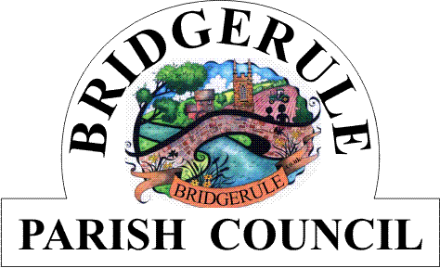

**Clerk to the Council: Amanda Harvey e-mail: bridgerulecouncil@outlook.com**

**To: All Members of Bridgerule Parish Council** 13th May 2024

Dear Councillors

You are hereby summoned to attend the **ANNUAL MEETING** of Bridgerule Parish Council, to be held in the **Village Hall, Bridgerule on Tuesday, 21st May 2024, commencing at 7.15 p.m.** for the purpose of transacting the following business. In accordance with The Public Bodies (Admissions to Meetings) Act 1960 members of the public are welcome to attend.

Yours sincerely

**Amanda Harvey**

**Parish Clerk**

**AGENDA**

**1.** **To Elect the Chairman for the Year 2024/2025**

**2. The Chairman Will Read and Sign the Prescribed ‘Declaration of Acceptance of Office’**

**3. To Elect the Deputy Chairman for the Year 2024/2025**

**4. Apologies for Absence** (Please make any apologies known to the Parish Clerk)

**5. Declarations of Interests** – to receive declarations of personal and pecuniary interests in respect of items on this Agenda.

**5.** **Council Meeting Minutes** – to approve and sign the Minutes of the Council ‘s Annual Meeting held on 23rd May 2023 as a correct record.

**6. Matters Arising** – to consider matters arising from the Annual Parish Minutes of 23rd May 2023 Meeting, not already covered by the Agenda. For information only.

**7. Public Open Question Time-** To receive questions from the Public. Each member of the public may have up

**t**o 2 minutes time. Standing Orders will be suspended during this session.

**8. To Receive Annual Reports from, County Councillor, District Councillor, Chairman, and other**

**Parish committees or bodies.**

**9. To Ratify and Adopt the Code of Conduct, Standing orders and Financial Regulations as Prescribed by NALC for the 2024/25 year.**

**11. To Ratify the Appointment of Gareth Pollard Chartered Accountant as Bridgerule Parish Council’s Accountants for 2024/25 and to Ratify the Insurance for the year 2024/2025 with Community First Ltd**

**12. To Ratify and adopt the GDPR Policy and Agree Data Protection Officer for the Council for the 2024/25**

**13. To approve Risk Assessments and the Asset Register for 2024/2025**

**14. To Agree and sign the AGAR form for the financial year ended March 2024 and to approve the Annual**

**Accounts for of year 2023-2024.**

**15. To Appoint Representatives to the Following Outside Bodies: i. Playground and Open Spaces**

**ii. Football Club iii. Bridgerule Village Hall Ltd**

**18. Meeting Close :**