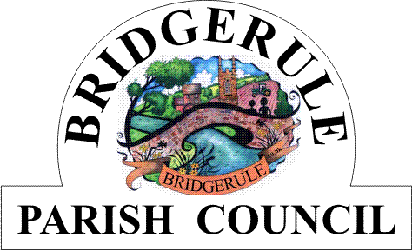
Clerk to the Council: Amanda Harvey 07866 452955 e-mail: Bridgerulecouncil@outlook.com

To: All Members of Bridgerule Parish Council 14th November 2023

Dear Councillor,
You are hereby summoned to attend a Meeting of Bridgerule Parish Council, to be held in the Parish Hall, on Tuesday 21st November 2023, at 7.30 pm for the purpose of transacting the following business.In accordance with The Public Bodies (Admissions to Meetings) Act 1960 members of the public are welcome to attend.
Yours sincerely

Amanda Harvey
Parish Clerk
AGENDA

1. Apologies for absence. (Please make any apologies known to the Parish Clerk).

2. Declaration of Interests – To receive declarations of personal and prejudicial interests in respect of items on this agenda.

3. Public Open Question Time – To receive questions from the Public. Each member of the Public may have up to 2 minutes time, the session to last no more than 10 minutes in total. Standing Orders will be suspended during this session.

4. County Councillors Report – If present the Cllr will provide a report for information only

5. District Councillors Report -

6. Council Meeting Minutes – To approve and sign the Minutes of the Council Meeting held on the 17th of October 2023.

7. Matters Arising - To consider matters arising from the Minutes 17th October 2023 Meeting, not already covered by the Agenda. For information only.

8. To Receive Correspondence – To receive details of correspondence received and sent from 17th October 2023 to the 21st of November 2023 and make decisions on, and actions to be taken on, matters arising from these

9. Chairmans Report

10. Accounts and accounts due for payment – To receive and approve the accounts due for payment and monthly finance sheets.

11. Highways, Vas Signs and Speedwatch Update

12. Charitable Grants- To consider applications received and appropriate funding.

13. Planning –

1/1021/2023/FUL – Erection of a garden room, (Re-submission of 1/0641/2023/FUL, Pale Park,
Marhamchurch, Bude, Devon

1/1022/2023/LBC - Erection of a garden room, (Re-submission of 1/0642/2023/LBC), Pale Park,
Marhamchurch, Bude, Devon.

14. New Unity Bank Account – to discuss and approve transfer of funds from Current account into Deposit Account.

15. Village Hall/Shop Update

16. Clerks Report-

17. Exchange of Information - With prior permission of the Chairman, to exchange information only on any other subject.

18. Close and date of next meeting –

