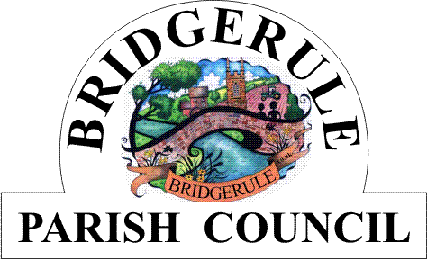
Clerk to the Council: Amanda Harvey 07866 452955 e-mail: Bridgerulecouncil@outlook.com

To: All Members of Bridgerule Parish Council 11th July 2023

Dear Councillor,
You are hereby summoned to attend a Meeting of Bridgerule Parish Council, to be held in the Parish Hall, on Tuesday 18th July 2023, at 7.45pm for the purpose of transacting the following business.In accordance with The Public Bodies (Admissions to Meetings) Act 1960 members of the public are welcome to attend.
Yours sincerely
Amanda Harvey
Parish Clerk
AGENDA

1. Apologies for absence. (Please make any apologies known to the Parish Clerk).

2. Declaration of Interests – To receive declarations of personal and prejudicial interests in respect of items on this agenda.

3. Public Open Question Time – To receive questions from the Public. Each member of the Public may have up to 2 minutes time, the session to last no more than 10 minutes in total. Standing Orders will be suspended during this session.

4. County Councillors Report – If present the Cllr will provide a report for information only

5. District Councillors Report -

6. Police Report –

7. Council Meeting Minutes – To approve and sign the Minutes of the Council Meeting held on the 20th of June 2023.

8. Matters Arising - To consider matters arising from the Minutes 20th June 2023 Meeting, not already covered by the Agenda. For information only.

9. To Receive Correspondence – To receive details of correspondence received and sent from 20th June 2023 to the 18th of July 2023 and make decisions on, and actions to be taken on, matters arising from these

10. Chairmans Report

11. Accounts and accounts due for payment – To receive and approve the accounts due for payment and monthly finance sheets. To discuss possible Transfer of funds from Current Account to Reserve Account.

12. Highways and Speedwatch Update.

13. Vas Signs Update and extension of 30mph zones within the village – to include alternative additional new sites for VAS sign poles

14. Grass cutting payment for Bridgerule Football Club 2023.

13. Car park Signage.

14. Planning –

1/0579/2023/FUL- Conversion of Barns to 5no: residential units(Variation of condition of planning approval 1/0767/2021/FUL), Lodgeworthy Farm, Bridgerule, Devon. E227509 N 102475.

1/0642/2023//LBC – Oak Garden Room, Pale Park, Marhamchurch, Bude, Devon. E225709 N 101916
1/0641/2023/FUL – Oak Garden Room, Pale Park, Marhamchurch, Bude, Devon. E225709 N 101916

16. Village Hall/Shop Update

19. Clerks Report-

20. Exchange of Information - With prior permission of the Chairman, to exchange information only on any other subject.

21. Close and date of next meeting –

