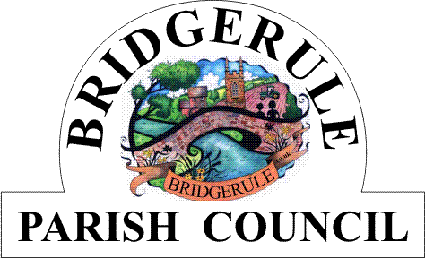
Clerk to the Council: Amanda Harvey 07866 452955 e-mail: Bridgerulecouncil@outlook.com

To: All Members of Bridgerule Parish Council 8th November 2022

Dear Councillor,

You are hereby summoned to attend a Meeting of Bridgerule Parish Council, to be held in the Parish Hall, on Tuesday 15th November 2022, at 7.45pm for the purpose of transacting the following business.In accordance with The Public Bodies (Admissions to Meetings) Act 1960 members of the public are welcome to attend.
Yours sincerely

Amanda Harvey
Parish Clerk
AGENDA

1. Apologies for absence. (Please make any apologies known to the Parish Clerk).

2. Declaration of Interests – To receive declarations of personal and prejudicial interests in respect of items on this agenda.

3. Public Open Question Time – To receive questions from the Public. Each member of the Public may have up to 2 minutes time, the session to last no more than 10 minutes in total. Standing Orders will be suspended during this session.

4. County Councillors Report – If present the Cllr will provide a report for information only

5. District Councillors Report -

6. Police Report –

7. Council Meeting Minutes – To approve and sign the Minutes of the Council Meeting held on the 18th of October 2022

8. Matters Arising - To consider matters arising from the Minutes 18th October 2022 Meeting, not already covered by the Agenda. For information only.

9. Community Speedwatch Scheme and Possible purchase of VAS Speed Warning Sign-
With Guest speaker Cllr. DC from Holsworthy Hamlets Parish Council.

10. To Receive Correspondence – To receive details of correspondence received and sent from 18th October 2022 to the 15th of November 2022 and make decisions on, and actions to be taken on, matters arising from these.

11. Accounts and accounts due for payment – To receive and approve the accounts due for payment and monthly finance sheets.

12. Chairmans Report.

13. Charitable Grants 2022 – to discuss applications received and allocations.

14. Planning – 1/0704/2022/REM – development adjacent to Carn Venn, Bridgerule, 5 dwellings, name of new street.

15. Village Hall and Community Shop Plans.

16. Car Park and Highways

17. Clerk’s Report

18. Exchange of Information – With prior permission of the Chairman, to exchange information only on any other subject.

19. Close and date of next meeting.

